**Christopher Mendes – Project #1**

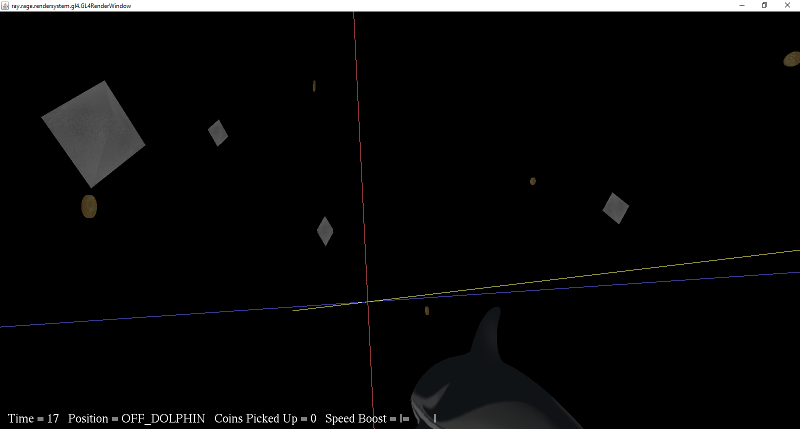

**To Compile and Run:**

You can just use compile.bat and run.bat

**NOTE:** I had a problem with the jinput working and had to put an extra option in the run.bat file which is -Djava.library.path="C:\Program Files (x86)\javagaming\jinput\lib". I left the line without it to run first. If it gives the jinput error, delete the first line of the run.bat, delete ‘rem’ in front of the line, and replace the path part to the jinput\lib folder.

**Game Manual**

**Inputs**

* Press W to move forward
* Press S to move backward
* Press A to move right
* Press D to move left
* Press UP ARROW to turn camera upwards
* Press DOWN ARROW to turn camera downwards
* Press RIGHT ARROW to turn camera right
* Press LEFT ARROW to turn camera left
* Press SPACE to switch ON and OFF the dolphin
* Press SHIFT for temporary boost when a coin is collected

**How Game Is Played**

One must collect all the coins that are spinning in the game. They cannot be picked up on the dolphin.

**Extra Game Activity**

There is a special speed boost that you can use for 3 seconds by pushing SHIFT. The game gives you one to start off with. When you collect a coin, it will partially re-fill the meter. You can have up to five speed boosts at a time.

**Extra Game Object**

There are slow rotating Diamonds floating around the sky.

**Requirements NOT Completed**

* The Gamepad inputs are programmed in, but I could not properly test it because as soon as the game starts, the game just starts moving me around and spinning. The Sprint and Mount buttons do work though.

**Other Special Add-Ons**

* None

**Testing**

I was not able to test my game ahead of time on any of the computers in 5029.

**Extra Assets**

* I added the coin object and textures that I got from <https://free3d.com/3d-model/coin-4532.html> which gives freedom to use for personal use.
* I also got a silver texture that was allowed for personal use from a guy on deviant art.